Experiment 3: Fourier analysis

Objective: To understand the Fourier series.
To analyze signals in both time and frequency domains

Background information
In the early 1800s, Jean Baptiste Joseph Fourier discovered that a periodic signal may be synthesized by a combination of sinusoidal waveforms. This discovery led to the famous Fourier series that we are familiar with today. Fourier series refers to the decomposition of any periodical function x(t) into sinusoids having frequencies which are integral multiples of the original periodic function.
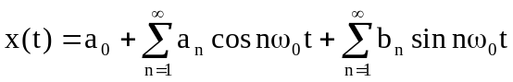

In this experiment, we shall try to synthesize some standard periodic functions with the help of Fourier series. We will also try to analyze the frequency content of some periodic signals and attempt to reconstruct them using Fourier series.

Procedure 1: Synthesis of a periodic signal
- For a square wave, the Fourier series can be expressed as:
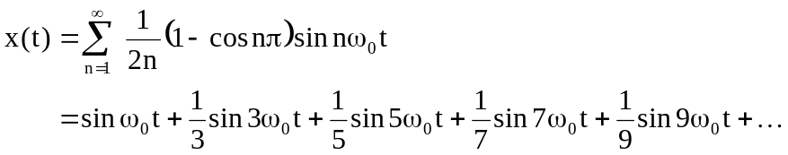

With the help of Simulink, we will try to synthesize the square wave by summing the sinusoids together.

- Create a new model as shown in the following diagram, Fig 3.1. See the previous experiment for the procedure for the creation of Simulink models.

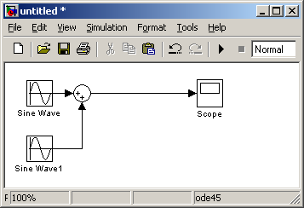
Fig 3.1
Double click on the 'Sine Wave' block and set the amplitude of the sine wave to 1 and the frequency to 1 rad/sec. Repeat the process for the 'Sine Wave' block, setting its amplitude to 1/3 and the frequency to 3 rad/sec.

- Run the simulation and observe the result at the 'Scope' block.

Does the output resemble a square wave?

_____________________________________________________________________

- Add another sine term to the simulation model as shown. Change the amplitude of the new sine wave to 1/5 and frequency to 5 rad/sec as shown below.

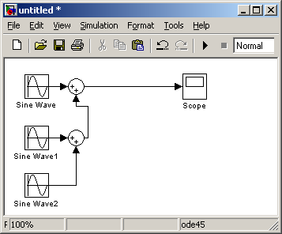

- Run the simulation and observe the result at the 'Scope' block.

Does the output resemble a square wave?

_____________________________________________________________________

- Repeat steps 1-4 and 1-5, adding more sine wave to the model, till there are at least 7 sine wave blocks (15th harmonic). Table 3-1 shows a summary of the amplitude and frequency of the various sine waves. Does the simulated output resemble the square wave more closely now?

_____________________________________________________________________

Block Name | Amplitude | Frequency (rad/sec)
Sine Wave | 1 | 1
Sine Wave 1 | 1/3 | 3
Sine Wave 2 | 1/5 | 5
Sine Wave 3 | 1/7 | 7
Sine Wave 4 | 1/9 | 9
Sine Wave 5 | 1/11 | 11
Sine Wave 6 | 1/13 | 13
Table 3–1

Procedure 2: Analysis of a periodic signal

- In this part of the experiment, we will be using the MATLAB software to help us in the analysis and then use the Simulink to do the synthesis. A periodic signal has been stored in the MATLAB format. Load the signal onto the MATLAB workspace by typing:

>>load ps1

A signal named "ps1" has been loaded onto the workspace.

- To study its frequency spectrum, type:

>>sigplot(ps1)

Sketch the signal in both time and frequency domains in Figure 3–1.

Signal in time domain
Magnitude spectrum
Figure 3–1
- From the sketch in Figure 3-2, tabulate the amplitude, frequency and phase of the sine waves that make up the periodic signal, "ps1".

 | Amplitude | Frequency (Hz) | Phase (rad)
Fundamental
2nd harmonic
3rd harmonic
4th harmonic
5th harmonic
Table 3–2
To achieve a more accurate result, you can use the zoom feature in the MATLAB display window to enlarge the portion of the plot which you are interested in. To do that, click on the icon:
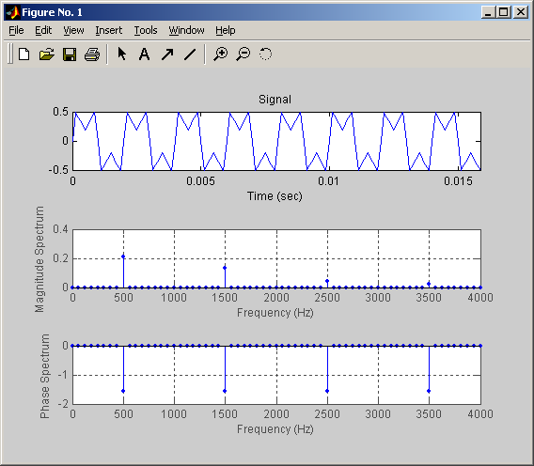

And then click at the point which you wish to enlarge or you can click the signal and the amplitude will be shown.

Conclusion: We have discovered that a square wave signal can be represented by a series of sinusoidal signals.

